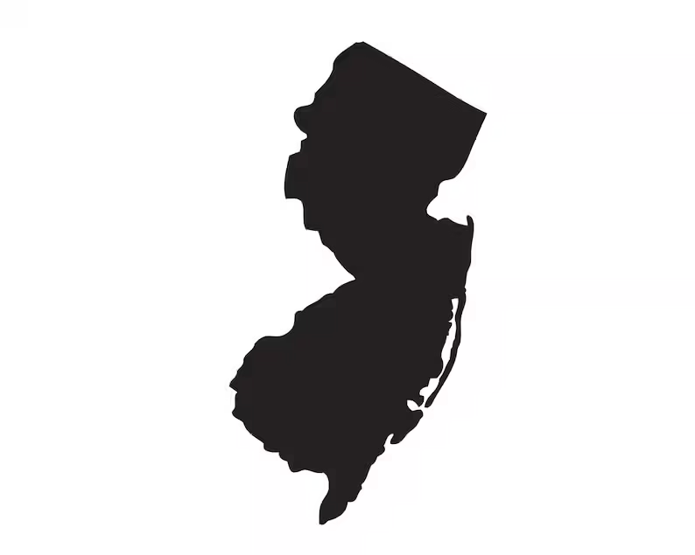Order of the Sons of Italy in America

Grand Lodge of New Jersey

510 Marlboro Avenue

Cherry Hill, NJ 08002

856-663-5800

[grandlodge@njsonsofitaly.com](mailto:grandlodge@njsonsofitaly.com)

Membership Application

Please Print Clearly

**Marlton Sons and Daughters of Italy Lodge # 2315**

**Name of Applicant___________________________________________________________**

**Address___________________________________________________________________**

**City_____________________________________________Zip Code___________________**

**Telephone - Home or Cell (circle one) ____________________________________________**

**Email _______________________________________ Date of Birth____________________**

**Italian Family Name_____________________________Occupation_____________________**

**Type of Membership (check one) ___Regular ____Social ___Member @ Large**

I certify that the above information is true and correct to the best of my knowledge and belief.

**Date______________ Applicant’s Signature __________________________________**

I certify that the applicant is fully eligible for the above membership and recommend membership approval.

**Date______________ Sponsor’s Signature_______________**____________________

Grand Lodge one time fee $30 per member Date Installed _________________

Marlton Lodge Annual Dues $60 per member Date Approved ________________

Make check Payable to SOI Marlton Lodge # 2315 Initiation Fee __________________